Group project: Demographic Trends and Forecasts in Saudi Arabia

Abdulrahman M Al-Mayouf ID 202002524

Ahmad Almarhoon ID 201901385

Hamad AlRatimah ID 201902399

Abdulrhman R Bubshait ID 201900495

Ahmed Alarfaj ID 201901774

Abdulaziz Al-Somali ID 201401660

Instructor: Dr. Sotirios Zygiaris

Dr. Aamir Abbas Chaudhry

BUSI 3331: Business Analytics

5 / 6 / 2024

Table of Contents

**Introduction** 3

**Data Cleaning and Reduction** 3

**Growth Rate Comparison** 4

**Population Forecast for Major Cities** 5

**Gender-Specific Growth Rate Analysis (2010-2022)** 6

**References** 8

# **Introduction**

This project undertakes a comprehensive analysis of population trends and forecasts within Saudi Arabia, focusing on key urban centers and demographic shifts over the period from 2010 to 2022. Through examining growth rates in major cities, projecting future demographic changes, and analyzing gender-specific population trends, this report aims to provide insights that can assist policymakers, urban planners, and researchers in understanding the dynamic patterns of urban population changes. The findings will facilitate informed decision-making geared towards sustainable urban development and demographic management in a rapidly evolving socio-economic landscape.

# **Data Cleaning and Reduction**

In our analysis, we have chosen to focus exclusively on three major regions: Ar Riyadh, Makkah Al Mukarramah, and the Eastern Region. These areas are among the most economically significant and densely populated in Saudi Arabia, making them particularly relevant for understanding national trends. To streamline our analysis and ensure a focused approach, data pertaining to other cities were excluded from our dataset. This reduction was performed to eliminate noise from less impactful regions and to concentrate our resources on analyzing trends that are most indicative of broader demographic changes in the country. This approach not only simplifies the data handling and analysis process but also enhances the accuracy and relevance of our findings to the targeted regions.

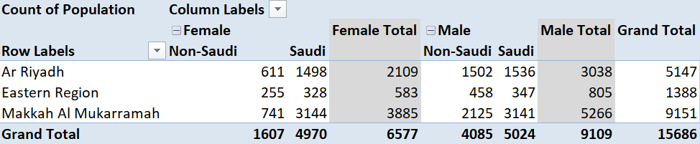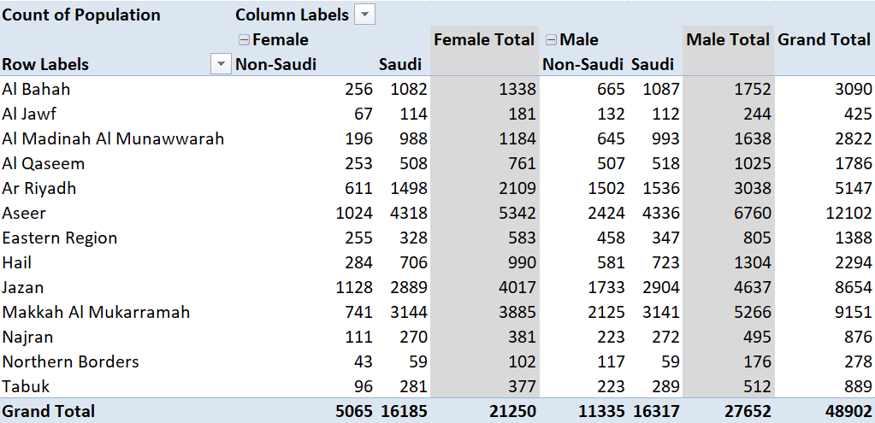

# **Growth Rate Comparison**

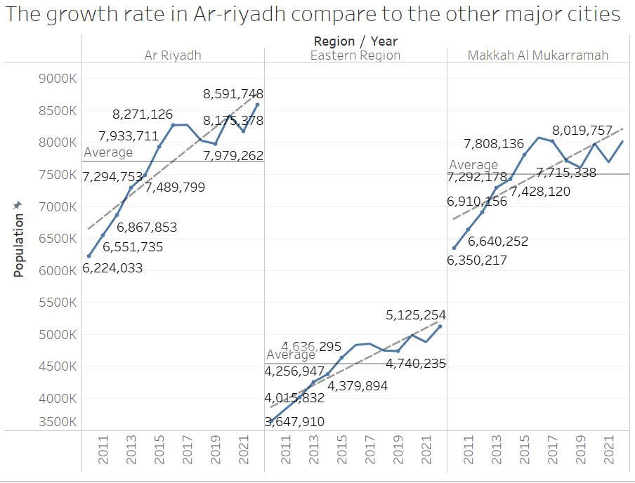Based on our analysis of the graph, we observed a decline in the data from 2017 to 2018, followed by a stabilization through 2019. In 2020, there was an uptick. Consequently, we aim to investigate the factors contributing to the drop in 2018.

The major citiessaw the largest declines in population among non-Saudi residents. These regions are critical economic and administrative centers in Saudi Arabia, typically attracting a large number of expatriates.

**Possible Reasons for the Decline:**

* + **Economic Factors:** Economic slowdowns, job market changes, or shifts in local industries could have discouraged expatriate residents from staying or new ones from arriving.
  + **Policy Changes:** Adjustments in immigration or labor laws, such as more stringent visa requirements or changes in residency and work permit regulations, may have played a significant role.
  + **Shifts in Social Conditions:** Changes in social benefits, healthcare, or education policies affecting non-Saudis could also influence their decision to reside in these regions.

The specific reasons behind these population trends would likely be tied to a combination of economic policies and shifts in the regulatory landscape affecting non-Saudis living in Saudi Arabia. Further analysis with contextual data from that period would be needed to pinpoint the exact causes.

# **Population Forecast for Major Cities**

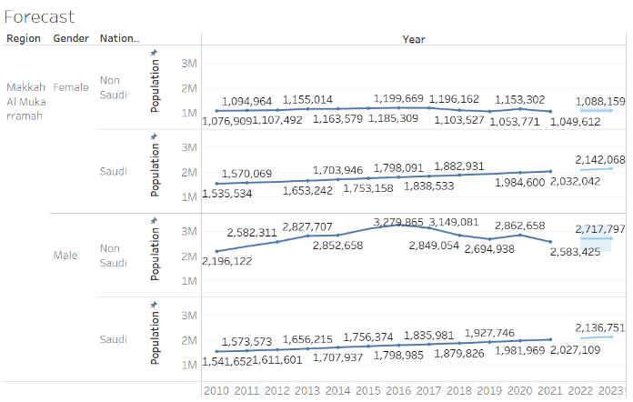

1. **Makkah Al Mukarramah**
   * The population forecast suggests a general trend of increase for both Saudi and non-Saudi populations across all genders. Notably, the non-Saudi female population is expected to stabilize after a slight decrease, while the Saudi female population shows a steady increase. This suggests a strengthening of demographic stability and possibly improved living conditions or job opportunities in the region which may attract more residents.
2. 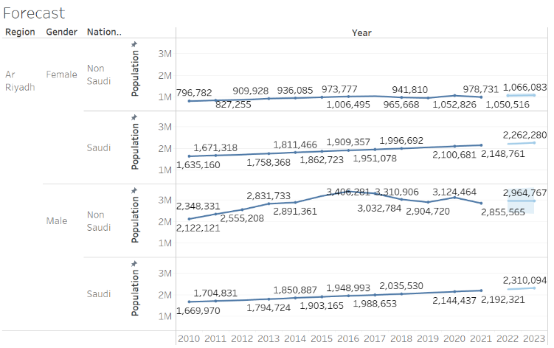**Ar Riyadh**
   * 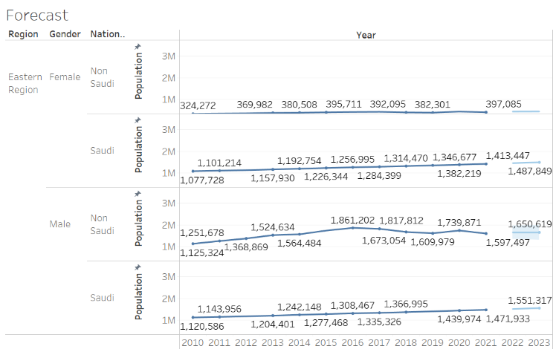In Ar Riyadh, the forecast indicates a consistent growth in population among Saudi males and females, suggesting ongoing urban development and economic opportunities that continue to attract Saudis to the capital. The non-Saudi population, particularly males, shows a more fluctuating trend but remains relatively stable, indicating that while there may be changes in expatriate workforce policies, the overall expatriate community remains integral to the region's demographic composition.
3. **Eastern Region**
   * The Eastern Region shows a steady increase in both Saudi and non-Saudi populations across all demographics. The consistent growth pattern across all groups suggests that the region remains a key area for both economic activity and residential attractiveness, likely driven by the oil and petrochemical industries which are significant employers in the area.

**General Forecast Insights:**

* Across all three regions, there is an observable trend of population growth among Saudi nationals, which might be linked to national policies aimed at increasing employment and quality of life for citizens.
* The non-Saudi population shows signs of stabilization, with some fluctuations that could be influenced by changes in labor laws and expatriate residency policies.
* Overall, these trends suggest robust urban and economic development in these key regions, making them attractive for both national and international residents looking for opportunities in Saudi Arabia.

These forecasts can aid policymakers and business leaders in planning for infrastructure, services, and economic activities to accommodate the expected changes in population dynamics.

# **Gender-Specific Growth Rate Analysis (2010-2022)**

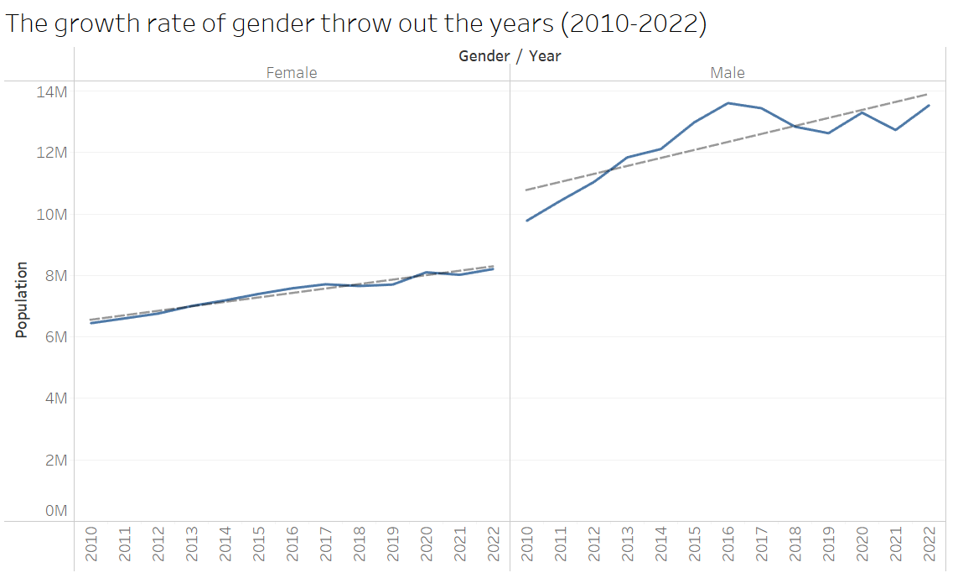

**Female** 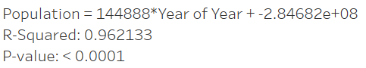

**Male**

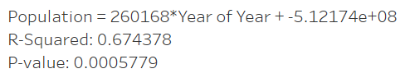

1. **Male Population Growth:**
   * Growth Rate: The trend line for male population growth shows an upward trajectory, but the fluctuation in growth rate is more pronounced than for females.
   * Regression Formula: Population = 260168 * Year - 5.12174e+08
   * R-Squared: 0.674378 - This value suggests that approximately 67.4% of the variance in male population growth can be explained by the year. While significant, it indicates that there are other factors not captured by the year alone that affect the male population size.
   * P-value: 0.0005779 - This low p-value indicates that the relationship between year and population size for males is statistically significant.
2. **Female Population Growth:**
   * Growth Rate: The female population growth curve is steadier and shows a more consistent upward trend compared to males.
   * Regression Formula: Population = 144888 * Year - 2.84682e+08
   * R-Squared: 0.962133 - A higher R-squared value compared to males, suggesting that about 96.2% of the variability in female population growth is predictable from the year. This indicates a very strong fit of the regression model to the data.
   * P-value: <0.0001 - The extremely low p-value confirms that the year is a highly significant predictor of the female population growth, reinforcing the reliability of the model.

Implications:

* The female population growth exhibits a more predictable pattern based solely on the year, which could suggest that factors influencing female population changes are more uniform or systemic over the years.
* The male population growth, while also showing a significant trend, has a lower R-squared value, indicating that other variables (perhaps economic factors, migration patterns, or policy changes) might play a more substantial role in influencing male population trends.
* The differences in growth patterns and statistical measures between genders could be useful for policymakers and planners, highlighting the need for gender-specific considerations in resource allocation, urban planning, and social services.

This analysis not only provides insights into the demographic trends but also underscores the importance of considering different factors that might uniquely affect male and female populations over the years.

# **References**

1. Populationbydetailedagebyregiongovernoratenationalityandgendercsv.xlsx
   * <https://od.data.gov.sa/Data/en/dataset/population-by-detailed-age>
2. Population2010-2022byregionnationalityandgendercsv. xlsx
   * <https://od.data.gov.sa/Data/en/dataset/population-growth>